PREDICTING SOLAR ENERGY YIELD USING
MACHINE LEARNING ALGORITHM

ABSTRACT
The increasing demand for energy and the growing concerns over climate change have highlighted the urgent need for intelligent systems that promote sustainable resource utilization. This project presents an Intelligent Solar Energy Yield Forecasting System that leverages data science techniques to predict energy usage patterns and optimize resource management. By analyzing historical consumption data, environmental factors, and usage behaviors, the system applies machine learning algorithms to generate accurate short-term and long-term energy forecasts.
The proposed model integrates data preprocessing, feature engineering, predictive modeling, and performance evaluation to ensure reliability and scalability. Forecasting results enable organizations and households to make informed decisions regarding energy allocation, load balancing, and peak demand management. Through proactive planning and optimized consumption strategies, the system contributes to reducing energy waste, lowering operational costs, and minimizing carbon emissions.

INTRODUCTION
Energy consumption has increased significantly over the past few decades due to rapid industrialization, urbanization, and technological advancements. While energy plays a vital role in economic growth and modern living standards, inefficient energy utilization contributes heavily to environmental degradation and rising carbon emissions. The need for sustainable energy management has therefore become a global priority. Organizations, industries, and households must adopt intelligent systems that not only monitor but also predict and optimize energy usage to ensure long-term environmental and economic sustainability.
Traditional energy management systems primarily focus on monitoring real-time consumption, offering limited support for predictive decision-making. However, with the emergence of data science, artificial intelligence, and machine learning technologies, it is now possible to analyze historical consumption patterns, identify trends, and forecast future energy demands with high accuracy. Forecasting enables proactive planning, efficient resource allocation, peak load management, and integration of renewable energy sources.
The Intelligent Energy Consumption Forecasting System aims to address these challenges by employing advanced data analytics and predictive modeling techniques to estimate future energy requirements. By collecting and analyzing large volumes of energy consumption data along with environmental and operational variables, the system provides actionable insights that help reduce energy waste, lower operational costs, and minimize carbon footprint.
This project emphasizes eco-friendly and optimized resource management by combining technology and sustainability principles. Through intelligent forecasting and data-driven decision-making, the system supports energy efficiency initiatives and contributes to building smarter, greener infrastructures aligned with global sustainability goals.

EXISTING SYSTEM
The existing energy management systems primarily focus on monitoring and recording energy consumption rather than predicting or optimizing it. Traditional systems rely on basic metering infrastructure, such as smart meters and manual readings, to track electricity usage. While these systems provide real-time or periodic consumption data, they often lack advanced analytical capabilities to forecast future energy demand accurately.
In many industries and residential settings, energy planning is based on historical averages or simple statistical methods. These approaches do not effectively account for dynamic factors such as weather conditions, seasonal variations, occupancy patterns, operational changes, or renewable energy integration. As a result, energy distribution and resource allocation are often reactive rather than proactive, leading to inefficiencies and increased operational costs.
Furthermore, conventional systems offer limited decision-support tools for carbon footprint reduction and sustainable energy management. They typically do not incorporate machine learning algorithms or predictive analytics to identify consumption trends, peak load periods, or potential energy-saving opportunities. This limitation reduces the ability of organizations to implement optimized strategies for load balancing, demand response, and eco-friendly resource utilization.
Although smart grid technologies have improved real-time monitoring and automation, many existing implementations still lack comprehensive forecasting mechanisms driven by data science. Consequently, energy management remains fragmented, less adaptive, and insufficient in addressing long-term sustainability goals.
These limitations highlight the need for an intelligent, data-driven forecasting system that can enhance prediction accuracy, optimize resource allocation, and significantly reduce environmental impact.

DISADVANTAGES

- High Initial Implementation Cost
Developing and deploying an intelligent forecasting system requires investment in data infrastructure, sensors, smart meters, cloud storage, and computing resources. This may be expensive for small organizations or households.
- Data Dependency
The accuracy of the system heavily depends on the quality and availability of historical data. Incomplete, noisy, or insufficient data can reduce forecasting performance.
- Complex Model Maintenance
Machine learning models require regular updates, retraining, and monitoring to maintain accuracy. Changes in consumption behavior or external conditions may reduce model effectiveness over time.
- Technical Expertise Requirement
Implementation and maintenance of data science models require skilled professionals in machine learning, data analytics, and system integration.
- Cybersecurity Risks
Since the system may rely on IoT devices, cloud platforms, and real-time data transmission, it can be vulnerable to cyberattacks or data breaches if not properly secured.
- Prediction Uncertainty
Forecasting models cannot guarantee 100% accuracy. Unexpected events such as sudden weather changes, economic shifts, or emergencies may affect prediction reliability.
- Integration Complexity
Integrating the system Scalability Challenges
Handling large-scale real-time data from multiple sources can create performance and storage challenges.
- with existing infrastructure, smart grids, or renewable energy systems may require additional customization and configuration

ADVANTAGES
- Provides accurate energy consumption forecasting.
- Optimizes resource utilization and reduces energy waste.
- Lowers operational costs through efficient load management.
- Reduces carbon footprint and supports sustainability.
- Enables better integration of renewable energy sources.
- Supports proactive and data-driven decision-making.
- Scalable for residential, commercial, and industrial use.

SYSTEM ARCHITECTURE
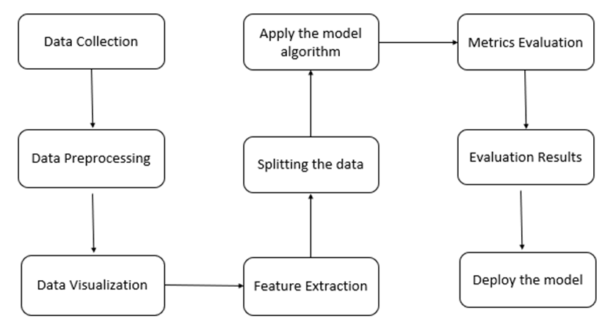
SYSTEM MODULES
1. Data Collection
The foundation of any machine learning model is high-quality data. In the context of traffic prediction, data collection involves gathering traffic flow information from multiple sources. These include real-time data from road sensors (loop detectors, cameras), GPS data from vehicles, weather reports, and historical traffic datasets maintained by transport authorities or open data portals. The data typically contains time stamps, vehicle counts, road segment IDs, speeds, congestion levels, weather conditions, and incident reports. Tools such as APIs, web scraping, and IoT gateways are used to automate the data acquisition process for real-time analytics.
2. Data Preprocessing
Raw traffic data is often noisy and incomplete, making preprocessing a crucial step. This involves cleaning the dataset by removing or imputing missing values, filtering outliers (like unusually high speed readings), and converting categorical features (e.g., weather conditions or day types) into numerical formats using encoding techniques. Time features may be converted into cyclical features (e.g., hour → sine and cosine) to preserve continuity. Scaling or normalization is also applied to bring all numerical features to a common range, ensuring stable model training and performance.
3. Feature Extraction
Feature extraction focuses on identifying and selecting the most relevant variables that influence traffic patterns. Common features include the hour of the day, day of the week, holiday indicators, vehicle count, average speed, road segment ID, weather condition, and accident presence. Temporal features can be extracted from timestamps to capture daily or weekly traffic trends. Feature engineering may also involve creating new features like “congestion index” or “peak hour flag” to boost prediction accuracy. Proper feature extraction is critical, as it directly affects model performance and interpretability.

4. Data Visualization
To better understand traffic behavior and validate data quality, data visualization techniques are employed. Line charts can show traffic flow over time, heatmaps may visualize congestion levels across regions, and bar graphs can compare vehicle counts on different days or hours. Correlation matrices help identify relationships between variables. Geospatial visualization using platforms like Google Maps or Folium can display traffic intensity across roads. These visual insights assist stakeholders in interpreting patterns and guide the selection of features for modeling.
5. Splitting the Data
Before training a machine learning model, the dataset is divided into training and testing sets, often using an 80:20 or 70:30 split. The training set is used to teach the model, while the testing set evaluates its performance on unseen data. In time series forecasting, data is usually split based on chronological order rather than random shuffling to preserve temporal dependencies. Cross-validation techniques like k-fold or time-based cross-validation can also be used for more robust evaluation, especially when working with limited data.
6. Applying Machine Learning Algorithm/Model
Various machine learning algorithms can be applied for traffic prediction. Linear Regression and Decision Trees may be used for simple relationships, while advanced models like Random Forest, Gradient Boosting, or Support Vector Regression (SVR) handle more complex patterns. For time-series traffic forecasting, Recurrent Neural Networks (RNNs) or Long Short-Term Memory (LSTM) models are highly effective due to their ability to retain temporal memory. The model is trained using the training data and tuned using techniques such as hyperparameter optimization to improve generalization.

7. Model Evaluation
After training, the model’s performance is evaluated using the testing data. The predicted traffic values are compared against actual observations. Visualization of predicted vs. actual values (e.g., line plots or scatter plots) can provide a visual sense of the model’s accuracy. Evaluation helps determine whether the model is underfitting, overfitting, or generalizing well. This phase may involve retraining the model with different algorithms or feature sets if performance is unsatisfactory.
8. Evaluation Metrics
The system uses standard regression evaluation metrics to assess prediction quality. These include:
- Mean Absolute Error (MAE): Measures average absolute difference between predicted and actual values.
- Root Mean Squared Error (RMSE): Gives higher weight to large errors, useful for identifying outliers.
- Mean Squared Error (MSE): Represents the average squared difference between estimated and actual values.
- R² Score (Coefficient of Determination): Measures how well future outcomes are likely to be predicted by the model.
These metrics help identify which model performs best and guide further optimization steps.
9. Model Deployment
Once a satisfactory model is trained and evaluated, it is deployed to a live environment. Deployment can be done via cloud platforms (like AWS, Azure, or GCP) using services such as Flask, FastAPI, or Streamlit for web apps. The deployed model accepts user inputs (e.g., time, road ID) and returns real-time traffic predictions. A user interface can display the results, and APIs can be exposed to integrate predictions into mobile apps or transport management dashboards. The system should also include model monitoring tools to detect drift, performance degradation, and the need for retraining over time.
Would you like a diagram or code snippet for any of these phases (e.g., model training, deployment with Flask/Streamlit, or visualization)?

SYSTEM REQUIREMENTS

HARDWARE REQUIREMENTS
Component | Specification/Description
Processor (CPU) | Intel Core i5/i7 or equivalent, 2.5 GHz or higher
RAM | Minimum 8 GB, recommended 16 GB or more
Storage | At least 500 GB HDD or SSD

SOFTWARE REQUIREMENTS
Operating System | Windows 10/11,
Programming Languages | Python 3.x
Web Framework Flask

FUNCTIONAL REQUIREMENTS
- Data Collection Module
The system shall collect historical and real-time energy consumption data from smart meters, IoT devices, or databases.
- Data Preprocessing
The system shall clean, normalize, and transform raw data to remove noise, missing values, and inconsistencies.
- Feature Extraction and Selection
The system shall identify relevant features such as time, weather conditions, seasonal patterns, and usage behavior for accurate forecasting.
- Energy Consumption Forecasting
The system shall apply machine learning algorithms to predict short-term and long-term energy consumption.
- Model Training and Evaluation
The system shall train predictive models using historical data and evaluate performance using appropriate metrics (e.g., MAE, RMSE, accuracy).
- Real-Time Monitoring
The system shall provide real-time monitoring of energy usage and compare it with predicted values.
- Alert and Notification System
The system shall generate alerts for abnormal energy consumption or peak load conditions.
- Report Generation
The system shall generate analytical reports and visual dashboards for users and administrators.
- Carbon Footprint Estimation
The system shall estimate carbon emissions based on energy consumption patterns.
- User Management
The system shall allow authorized users to access, manage, and analyze energy data securely

.

NON-FUNCTIONAL REQUIREMENTS
- Performance
The system should process large volumes of energy data efficiently and generate forecasts within an acceptable response time.
- Accuracy
The forecasting model should maintain high prediction accuracy with minimal error rates.
- Scalability
The system should be scalable to handle increasing data volumes and multiple users or locations.
- Reliability
The system should operate continuously with minimal downtime and ensure consistent performance.
- Security
The system should protect sensitive energy data using authentication, authorization, and encryption mechanisms.
- Usability
The user interface should be simple, intuitive, and easy to navigate for all users.
- Maintainability
The system should allow easy updates, model retraining, and future enhancements.
- Compatibility
The system should integrate with existing smart meters, IoT devices, and smart grid infrastructure.

UML DIAGRAMS

The Unified Modeling Language (UML) is used to specify, visualize, modify, construct and document the artifacts of an object-oriented software intensive system under development. UML offers a standard way to visualize a system's architectural blueprints, including elements such as:

● actors

● business processes

● (logical) components

● activities

● programming language statements

● database schemas, and

● Reusable software components.

UML combines best techniques from data modeling (entity relationship diagrams), business modeling (work flows), object modeling, and component modeling. It can be used with all processes, throughout the software development life cycle, and across different implementation technologies. UML has synthesized the notations of the Booch method, the Object-modeling technique (OMT) and Object-oriented software engineering (OOSE) by fusing them into a single, common and widely usable modeling language. UML aims to be a standard modeling language which can model concurrent and distributed systems.

Sequence Diagram:

Sequence Diagrams Represent the objects participating the interaction horizontally and time vertically. A Use Case is a kind of behavioral classifier that represents a declaration of an offered behavior. Each use case specifies some behavior, possibly including variants that the subject can perform in collaboration with one or more actors. Use cases define the offered behavior of the subject without reference to its internal structure. These behaviors, involving interactions between the actor and the subject, may result in changes to the state of the subject and communications with its environment. A use case can include possible variations of its basic behavior, including exceptional behavior and error handling.

Activity Diagrams-:

Activity diagrams are graphical representations of Workflows of stepwise activities and actions with support for choice, iteration and concurrency. In the Unified Modeling Language, activity diagrams can be used to describe the business and operational step-by-step workflows of components in a system. An activity diagram shows the overall flow of control.

Usecase diagram:

• UML is a standard language for specifying, visualizing, constructing, and documenting the artifacts of software systems.

• UML was created by Object Management Group (OMG) and UML 1.0 specification draft was proposed to the OMG in January 1997.

• OMG is continuously putting effort to make a truly industry standard.

• UML stands for Unified Modeling Language.

• UML is a pictorial language used to make software blue prints

Class diagram

The class diagram is the main building block of object-oriented modeling. It is used for general conceptual modeling of the systematic of the application, and for detailed modeling translating the models into programming code. Class diagrams can also be used for data modeling.[1] The classes in a class diagram represent both the main elements, interactions in the application, and the classes to be programmed.

In the diagram, classes are represented with boxes that contain three compartments:

The top compartment contains the name of the class. It is printed in bold and centered, and the first letter is capitalized.

The middle compartment contains the attributes of the class. They are left-aligned and the first letter is lowercase.

The bottom compartment contains the operations the class can execute. They are also left-aligned and the first letter is lowercase.

Usecase diagram

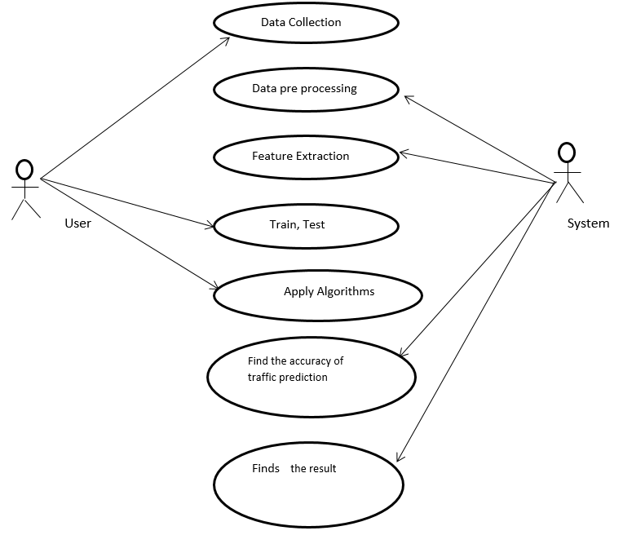

Sequence diagram

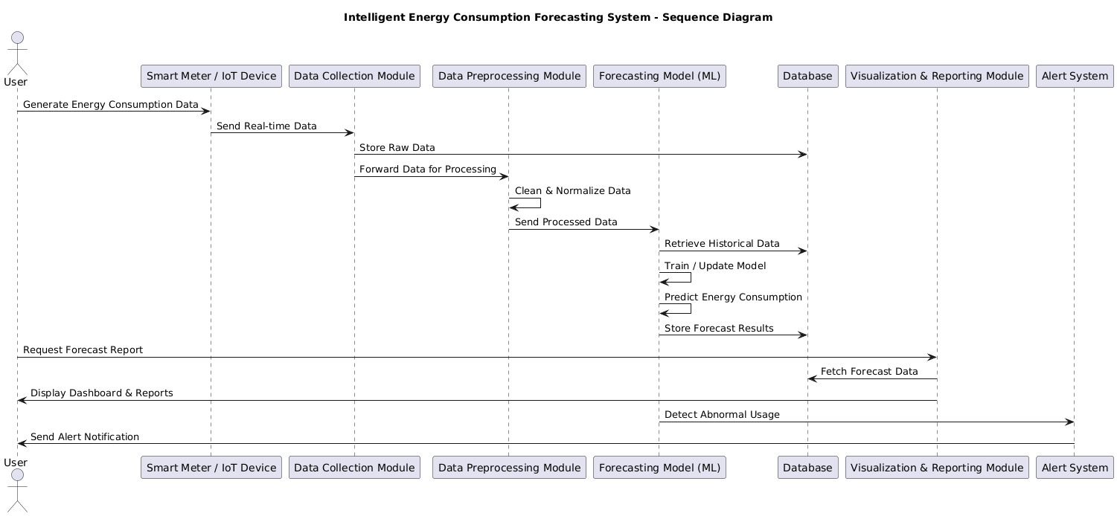

Activity diagram

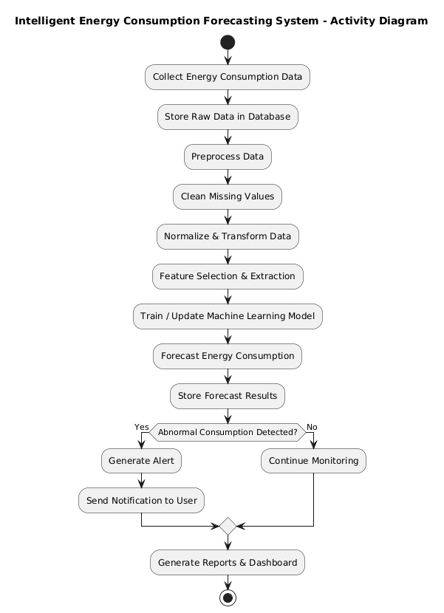

Deployment diagram

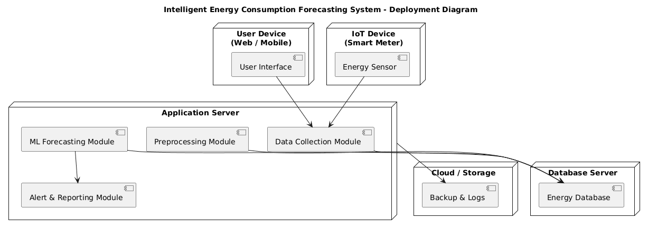

Collaboration diagram

Class diagram

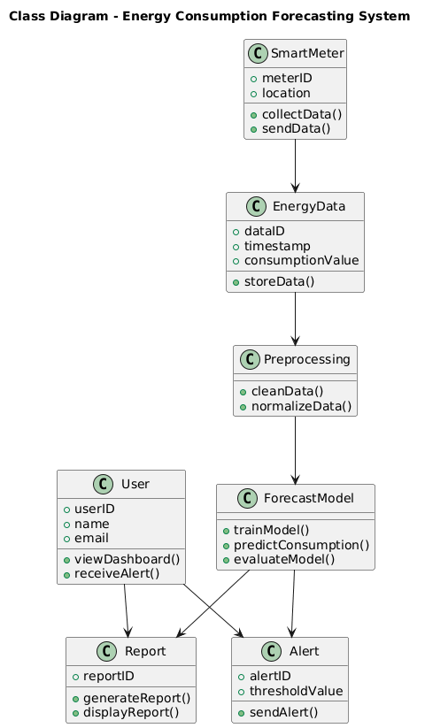

Er diagram

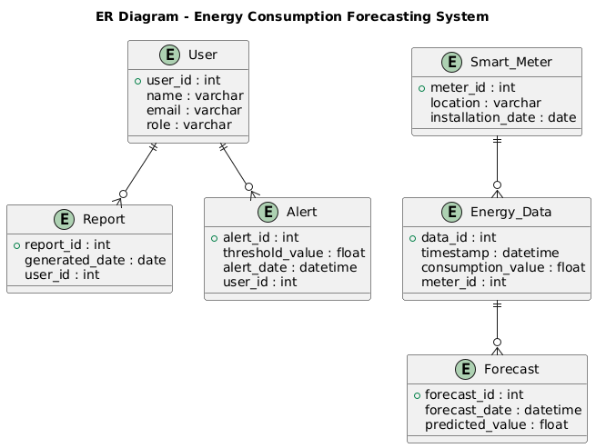

Data Flow Diagrams

The abbreviation for Information Stream Outline is DFD. DFD deals with the information flow of a framework or an interaction. Additionally, it provides information on the data sources, outcomes, and actual interactions for each factor. There are no circles, choice criteria, or control streams in DFD. A flowchart can make sense of explicit tasks reliant on the type of data.

It is a graphical tool that makes communicating with clients, supervisors, and other faculty members easier. It is useful for dissecting both the current and the suggested structure.

It provides a summary of the framework procedures for what information there is.

What adjustments are made, what data is archived, what outputs are made, and so on.

There are various ways to address the Information Stream Outline. There are organised investigation exhibiting gadgets at the DFD. Information Stream graphs are well known because they let us visualise the important steps and information involved in programming framework activities.

Four sections make up the information stream graph:

Process Due to dealing capability, a framework's ability to produce change is affected. Images of a conversation may be round, oval, square, or rectangular with rounded corners. The cycle is given a brief name that communicates its essence in a single word or statement.

Information Stream Information stream depicts the data moving between various pieces of the frameworks. The bolt image is the image of information stream. An engaging name ought to be given to the stream to decide the data which is being moved. Information stream additionally addresses material alongside data that is being moved. Material movements are displayed in frameworks that are not simply useful. A given stream ought to just exchange a solitary kind of data. The course of stream is addressed by the bolt which can likewise be bi-directional.

Distribution center The information is put away in the stockroom for sometime in the future. Two flat lines address the image of the store. The distribution center is essentially not confined to being an information record rather it very well may be in any way similar to an envelope with reports, an optical circle, a file organizer. The information distribution center can be seen autonomous of its execution. At the point when the information stream from the stockroom it is considered as information perusing and when information streams to the distribution center it is called information passage or information refreshing.

Eliminator The Eliminator is an outer substance that stands beyond the framework and speaks with the framework. It very well may be, for instance, associations like banks, gatherings like clients or various divisions of a similar association, which isn't a piece of the model framework and is an outside element. Displayed frameworks additionally speak with eliminator.

LEVEL0

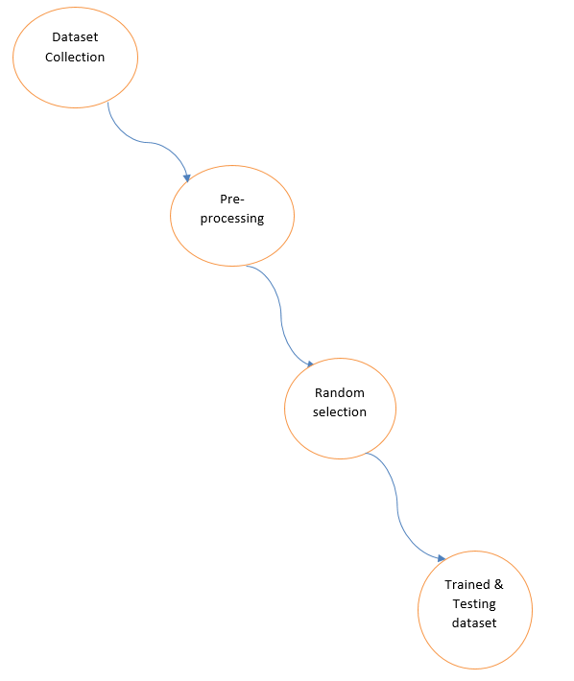

LEVEL1

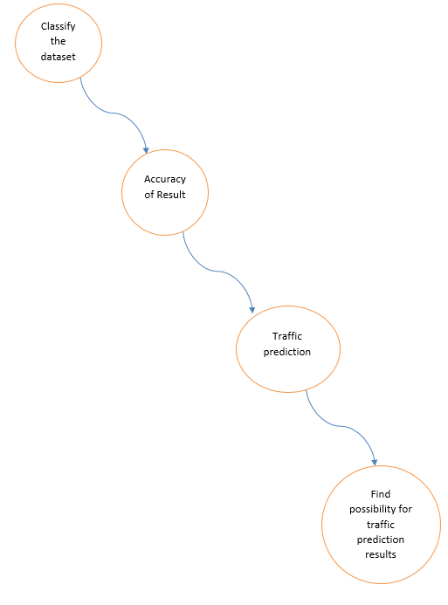

Domain Specification

MACHINE LEARNING

Machine Learning is a system that can learn from example through self-improvement and without being explicitly coded by programmer. The breakthrough comes with the idea that a machine can singularly learn from the data (i.e., example) to produce accurate results.

Machine learning combines data with statistical tools to predict an output. This output is then used by corporate to makes actionable insights. Machine learning is closely related to data mining and Bayesian predictive modeling. The machine receives data as input, use an algorithm to formulate answers.

A typical machine learning tasks are to provide a recommendation. For those who have a Netflix account, all recommendations of movies or series are based on the user's historical data. Tech companies are using unsupervised learning to improve the user experience with personalizing recommendation.

Machine learning is also used for a variety of task like fraud detection, predictive maintenance, portfolio optimization, automatize task and so on.

Machine Learning vs. Traditional Programming

Traditional programming differs significantly from machine learning. In traditional programming, a programmer code all the rules in consultation with an expert in the industry for which software is being developed. Each rule is based on a logical foundation; the machine will execute an output following the logical statement. When the system grows complex, more rules need to be written. It can quickly become unsustainable to maintain.

Machine Learning

How does Machine learning work?

Machine learning is the brain where all the learning takes place. The way the machine learns is similar to the human being. Humans learn from experience. The more we know, the more easily we can predict. By analogy, when we face an unknown situation, the likelihood of success is lower than the known situation. Machines are trained the same. To make an accurate prediction, the machine sees an example. When we give the machine a similar example, it can figure out the outcome. However, like a human, if its feed a previously unseen example, the machine has difficulties to predict.

The core objective of machine learning is the learning and inference. First of all, the machine learns through the discovery of patterns. This discovery is made thanks to the data. One crucial part of the data scientist is to choose carefully which data to provide to the machine. The list of attributes used to solve a problem is called a feature vector. You can think of a feature vector as a subset of data that is used to tackle a problem.

The machine uses some fancy algorithms to simplify the reality and transform this discovery into a model. Therefore, the learning stage is used to describe the data and summarize it into a model.

For instance, the machine is trying to understand the relationship between the wage of an individual and the likelihood to go to a fancy restaurant. It turns out the machine finds a positive relationship between wage and going to a high-end restaurant: This is the model

Inferring

When the model is built, it is possible to test how powerful it is on never-seen-before data. The new data are transformed into a features vector, go through the model and give a prediction. This is all the beautiful part of machine learning. There is no need to update the rules or train again the model. You can use the model previously trained to make inference on new data.

The life of Machine Learning programs is straightforward and can be summarized in the following points:

1. Define a question

2. Collect data

3. Visualize data

4. Train algorithm

5. Test the Algorithm

6. Collect feedback

7. Refine the algorithm

8. Loop 4-7 until the results are satisfying

9. Use the model to make a prediction

Once the algorithm gets good at drawing the right conclusions, it applies that knowledge to new sets of data.

Machine learning Algorithms and where they are used?

Machine learning can be grouped into two broad learning tasks: Supervised and Unsupervised. There are many other algorithms

Supervised learning

An algorithm uses training data and feedback from humans to learn the relationship of given inputs to a given output. For instance, a practitioner can use marketing expense and weather forecast as input data to predict the sales of cans.

You can use supervised learning when the output data is known. The algorithm will predict new data.

There are two categories of supervised learning:

Algorithm Name Description Type

Linear regression Finds a way to correlate each feature to the output to help predict future values. Regression

Logistic regression Extension of linear regression that's used for classification tasks. The output variable 3is binary (e.g., only black or white) rather than continuous (e.g., an infinite list of potential colors) Classification

Decision tree Highly interpretable classification or regression model that splits data-feature values into branches at decision nodes (e.g., if a feature is a color, each possible color becomes a new branch) until a final decision output is made Regression Classification

Naive Bayes The Bayesian method is a classification method that makes use of the Bayesian theorem. The theorem updates the prior knowledge of an event with the independent probability of each feature that can affect the event. Regression Classification

Support vector machine Support Vector Machine, or SVM, is typically used for the classification task. SVM algorithm finds a hyperplane that optimally divided the classes. It is best used with a non-linear solver. Regression (not very common) Classification

Random forest The algorithm is built upon a decision tree to improve the accuracy drastically. Random forest generates many times simple decision trees and uses the 'majority vote' method to decide on which label to return. For the classification task, the final prediction will be the one with the most vote; while for the regression task, the average prediction of all the trees is the final prediction. Regression Classification

AdaBoost Classification or regression technique that uses a multitude of models to come up with a decision but weighs them based on their accuracy in predicting the outcome Regression Classification

Gradient-boosting trees Gradient-boosting trees is a state-of-the-art classification/regression technique. It is focusing on the error committed by the previous trees and tries to correct it. Regression Classification

● Classification task

● Regression task

Classification

Imagine you want to predict the gender of a customer for a commercial. You will start gathering data on the height, weight, job, salary, purchasing basket, etc. from your customer database. You know the gender of each of your customer, it can only be male or female. The objective of the classifier will be to assign a probability of being a male or a female (i.e., the label) based on the information (i.e., features you have collected). When the model learned how to recognize male or female, you can use new data to make a prediction. For instance, you just got new information from an unknown customer, and you want to know if it is a male or female. If the classifier predicts male = 70%, it means the algorithm is sure at 70% that this customer is a male, and 30% it is a female.

The label can be of two or more classes. The above example has only two classes, but if a classifier needs to predict object, it has dozens of classes (e.g., glass, table, shoes, etc. each object represents a class)

Regression

When the output is a continuous value, the task is a regression. For instance, a financial analyst may need to forecast the value of a stock based on a range of feature like equity, previous stock performances, macroeconomics index. The system will be trained to estimate the price of the stocks with the lowest possible error.

Algorithm Description Type

K-means clustering Puts data into some groups (k) that each contains data with similar characteristics (as determined by the model, not in advance by humans) Clustering

Gaussian mixture model A generalization of k-means clustering that provides more flexibility in the size and shape of groups (clusters Clustering

Hierarchical clustering Splits clusters along a hierarchical tree to form a classification system.

Can be used for Cluster loyalty-card customer Clustering

Recommender system Help to define the relevant data for making a recommendation. Clustering

PCA/T-SNE Mostly used to decrease the dimensionality of the data. The algorithms reduce the number of features to 3 or 4 vectors with the highest variances. Dimension Reduction

Unsupervised learning

In unsupervised learning, an algorithm explores input data without being given an explicit output variable (e.g., explores customer demographic data to identify patterns)

You can use it when you do not know how to classify the data, and you want the algorithm to find patterns and classify the data for you

Application of Machine learning

Augmentation:

● Machine learning, which assists humans with their day-to-day tasks, personally or commercially without having complete control of the output. Such machine learning is used in different ways such as Virtual Assistant, Data analysis, software solutions. The primary user is to reduce errors due to human bias.

Automation:

● Machine learning, which works entirely autonomously in any field without the need for any human intervention. For example, robots performing the essential process steps in manufacturing plants.

Finance Industry

● Machine learning is growing in popularity in the finance industry. Banks are mainly using ML to find patterns inside the data but also to prevent fraud.

Government organization

● The government makes use of ML to manage public safety and utilities. Take the example of China with the massive face recognition. The government uses Artificial intelligence to prevent jaywalker.

Healthcare industry

● Healthcare was one of the first industry to use machine learning with image detection.

Marketing

● Broad use of AI is done in marketing thanks to abundant access to data. Before the age of mass data, researchers develop advanced mathematical tools like Bayesian analysis to estimate the value of a customer. With the boom of data, marketing department relies on AI to optimize the customer relationship and marketing campaign.

Example of application of Machine Learning in Supply Chain

Machine learning gives terrific results for visual pattern recognition, opening up many potential applications in physical inspection and maintenance across the entire supply chain network.

Unsupervised learning can quickly search for comparable patterns in the diverse dataset. In turn, the machine can perform quality inspection throughout the logistics hub, shipment with damage and wear.

For instance, IBM's Watson platform can determine shipping container damage. Watson combines visual and systems-based data to track, report and make recommendations in real-time.

In past year stock manager relies extensively on the primary method to evaluate and forecast the inventory. When combining big data and machine learning, better forecasting techniques have been implemented (an improvement of 20 to 30 % over traditional forecasting tools). In term of sales, it means an increase of 2 to 3 % due to the potential reduction in inventory costs.

Example of Machine Learning Google Car

For example, everybody knows the Google car. The car is full of lasers on the roof which are telling it where it is regarding the surrounding area. It has radar in the front, which is informing the car of the speed and motion of all the cars around it. It uses all of that data to figure out not only how to drive the car but also to figure out and predict what potential drivers around the car are going to do. What's impressive is that the car is processing almost a gigabyte a second of data.

Deep Learning

Deep learning is a computer software that mimics the network of neurons in a brain. It is a subset of machine learning and is called deep learning because it makes use of deep neural networks. The machine uses different layers to learn from the data. The depth of the model is represented by the number of layers in the model. Deep learning is the new state of the art in term of AI. In deep learning, the learning phase is done through a neural network.

Reinforcement Learning

Reinforcement learning is a subfield of machine learning in which systems are trained by receiving virtual "rewards" or "punishments," essentially learning by trial and error. Google's DeepMind has used reinforcement learning to beat a human champion in the Go games. Reinforcement learning is also used in video games to improve the gaming experience by providing smarter bot.

One of the most famous algorithms are:

● Q-learning

● Deep Q network

● State-Action-Reward-State-Action (SARSA)

● Deep Deterministic Policy Gradient (DDPG)

Applications/ Examples of deep learning applications

AI in Finance: The financial technology sector has already started using AI to save time, reduce costs, and add value. Deep learning is changing the lending industry by using more robust credit scoring. Credit decision-makers can use AI for robust credit lending applications to achieve faster, more accurate risk assessment, using machine intelligence to factor in the character and capacity of applicants.

Underwrite is a Fintech company providing an AI solution for credit makers company. underwrite.ai uses AI to detect which applicant is more likely to pay back a loan. Their approach radically outperforms traditional methods.

AI in HR: Under Armour, a sportswear company revolutionizes hiring and modernizes the candidate experience with the help of AI. In fact, Under Armour Reduces hiring time for its retail stores by 35%. Under Armour faced a growing popularity interest back in 2012. They had, on average, 30000 resumes a month. Reading all of those applications and begin to start the screening and interview process was taking too long. The lengthy process to get people hired and on-boarded impacted Under Armour's ability to have their retail stores fully staffed, ramped and ready to operate.

At that time, Under Armour had all of the 'must have' HR technology in place such as transactional solutions for sourcing, applying, tracking and onboarding but those tools weren't useful enough. Under armour choose HireVue, an AI provider for HR solution, for both on-demand and live interviews. The results were bluffing; they managed to decrease by 35% the time to fill. In return, the hired higher quality staffs.

AI in Marketing: AI is a valuable tool for customer service management and personalization challenges. Improved speech recognition in call-center management and call routing as a result of the application of AI techniques allows a more seamless experience for customers.

For example, deep-learning analysis of audio allows systems to assess a customer's emotional tone. If the customer is responding poorly to the AI chatbot, the system can be rerouted the conversation to real, human operators that take over the issue.

Apart from the three examples above, AI is widely used in other sectors/industries.

Artificial Intelligence

Difference between Machine Learning and Deep Learning

Machine Learning Deep Learning

Data Dependencies Excellent performances on a small/medium dataset Excellent performance on a big dataset

Hardware dependencies Work on a low-end machine. Requires powerful machine, preferably with GPU: DL performs a significant amount of matrix multiplication

Feature engineering Need to understand the features that represent the data No need to understand the best feature that represents the data

Execution time From few minutes to hours Up to weeks. Neural Network needs to compute a significant number of weights

Interpretability Some algorithms are easy to interpret (logistic, decision tree), some are almost impossible (SVM, XGBoost) Difficult to impossible

When to use ML or DL?

In the table below, we summarize the difference between machine learning and deep learning.

Machine learning Deep learning

Training dataset Small Large

Choose features Yes No

Number of algorithms Many Few

Training time Short Long

With machine learning, you need fewer data to train the algorithm than deep learning. Deep learning requires an extensive and diverse set of data to identify the underlying structure. Besides, machine learning provides a faster-trained model. Most advanced deep learning architecture can take days to a week to train. The advantage of deep learning over machine learning is it is highly accurate. You do not need to understand what features are the best representation of the data; the neural network learned how to select critical features. In machine learning, you need to choose for yourself what features to include in the model.

TensorFlow

the most famous deep learning library in the world is Google's TensorFlow. Google product uses machine learning in all of its products to improve the search engine, translation, image captioning or recommendations.

To give a concrete example, Google users can experience a faster and more refined the search with AI. If the user types a keyword a the search bar, Google provides a recommendation about what could be the next word.

Google wants to use machine learning to take advantage of their massive datasets to give users the best experience. Three different groups use machine learning:

● Researchers

● Data scientists

● Programmers.

They can all use the same toolset to collaborate with each other and improve their efficiency.

Google does not just have any data; they have the world's most massive computer, so TensorFlow was built to scale. TensorFlow is a library developed by the Google Brain Team to accelerate machine learning and deep neural network research.

It was built to run on multiple CPUs or GPUs and even mobile operating systems, and it has several wrappers in several languages like Python, C++ or Java.

In this tutorial, you will learn

TensorFlow Architecture

Tensor flow architecture works in three parts:

● Pre processing the data

● Build the model

● Train and estimate the model

It is called Tensor flow because it takes input as a multi-dimensional array, also known as tensors. You can construct a sort of flowchart of operations (called a Graph) that you want to perform on that input. The input goes in at one end, and then it flows through this system of multiple operations and comes out the other end as output.

This is why it is called TensorFlow because the tensor goes in it flows through a list of operations, and then it comes out the other side.

Where can Tensor flow run?

TensorFlow can hardware, and software requirements can be classified into

Development Phase: This is when you train the mode. Training is usually done on your Desktop or laptop.

Run Phase or Inference Phase: Once training is done Tensorflow can be run on many different platforms. You can run it on

● Desktop running Windows, macOS or Linux

● Cloud as a web service

● Mobile devices like iOS and Android

You can train it on multiple machines then you can run it on a different machine, once you have the trained model.

The model can be trained and used on GPUs as well as CPUs. GPUs were initially designed for video games. In late 2010, Stanford researchers found that GPU was also very good at matrix operations and algebra so that it makes them very fast for doing these kinds of calculations. Deep learning relies on a lot of matrix multiplication. TensorFlow is very fast at computing the matrix multiplication because it is written in C++. Although it is implemented in C++, TensorFlow can be accessed and controlled by other languages mainly, Python.

Finally, a significant feature of Tensor Flow is the Tensor Board. The Tensor Board enables to monitor graphically and visually what TensorFlow is doing.

List of Prominent Algorithms supported by TensorFlow

● Linear regression: tf. estimator .Linear Regressor

● Classification :tf. Estimator .Linear Classifier

● Deep learning classification: tf. estimator. DNN Classifier

● Booster tree regression: tf.estimator.BoostedTreesRegressor

● Boosted tree classification: tf.estimator.BoostedTreesClassifier

PYTHON OVERVIEW

Python is a high-level, interpreted, interactive and object-oriented scripting language. Python is designed to be highly readable. It uses English keywords frequently where as other languages use punctuation, and it has fewer syntactical constructions than other languages.

• Python is Interpreted: Python is processed at runtime by the interpreter. You do not need to compile your program before executing it. This is similar to PERL and PHP.

• Python is Interactive: You can actually sit at a Python prompt and interact with the interpreter directly to write your programs.

• Python is Object-Oriented: Python supports Object-Oriented style or technique of programming that encapsulates code within objects.

• Python is a Beginner's Language: Python is a great language for the beginner-level programmers and supports the development of a wide range of applications from simple text processing to WWW browsers to games.

History of Python

Python was developed by Guido van Rossum in the late eighties and early nineties at the National Research Institute for Mathematics and Computer Science in the Netherlands.

Python is derived from many other languages, including ABC, Modula-3, C, C++, Algol-68, SmallTalk, Unix shell, and other scripting languages.

Python is copyrighted. Like Perl, Python source code is now available under the GNU General Public License (GPL).

Python is now maintained by a core development team at the institute, although Guido van Rossum still holds a vital role in directing its progress.

Python Features

Python's features include:

Easy-to-learn: Python has few keywords, simple structure, and a clearly defined syntax. This allows the student to pick up the language quickly.

Easy-to-read: Python code is more clearly defined and visible to the eyes.

Easy-to-maintain: Python's source code is fairly easy-to-maintain.

A broad standard library: Python's bulk of the library is very portable and cross-platform compatible on UNIX, Windows, and Macintosh.

Interactive Mode: Python has support for an interactive mode which allows interactive testing and debugging of snippets of code.

Portable: Python can run on a wide variety of hardware platforms and has the same interface on all platforms.

Extendable: You can add low-level modules to the Python interpreter. These modules enable programmers to add to or customize their tools to be more efficient.

Databases: Python provides interfaces to all major commercial databases.

GUI Programming: Python supports GUI applications that can be created and ported to many system calls, libraries, and windows systems, such as Windows MFC, Macintosh, and the X Window system of Unix.

Scalable: Python provides a better structure and support for large programs than shell scripting.

Apart from the above-mentioned features, Python has a big list of good features, few are listed below:

• IT supports functional and structured programming methods as well as OOP.

• It can be used as a scripting language or can be compiled to byte-code for building large applications.

• It provides very high-level dynamic data types and supports dynamic type checking.

• IT supports automatic garbage collection.

• It can be easily integrated with C, C++, COM, ActiveX, CORBA, and Java.

Python is available on a wide variety of platforms including Linux and Mac OS X. Let's understand how to set up our Python environment.

ANACONDA NAVIGATOR

Anaconda Navigator is a desktop graphical user interface (GUI) included in Anaconda distribution that allows you to launch applications and easily manage conda packages, environments and channels without using command-line commands. Navigator can search for packages on Anaconda Cloud or in a local Anaconda Repository. It is available for Windows, mac OS and Linux.

Why use Navigator?

In order to run, many scientific packages depend on specific versions of other packages. Data scientists often use multiple versions of many packages, and use multiple environments to separate these different versions.

The command line program conda is both a package manager and an environment manager, to help data scientists ensure that each version of each package has all the dependencies it requires and works correctly.

Navigator is an easy, point-and-click way to work with packages and environments without needing to type conda commands in a terminal window. You can use it to find the packages you want, install them in an environment, run the packages and update them, all inside Navigator.

WHAT APPLICATIONS CAN I ACCESS USING NAVIGATOR?

The following applications are available by default in Navigator:

• Jupyter Lab

• Jupyter Notebook

• QT Console

• Spyder

• VS Code

• Glue viz

• Orange 3 App

• Rodeo

• RStudio

Advanced conda users can also build your own Navigator applications

How can I run code with Navigator?

The simplest way is with Spyder. From the Navigator Home tab, click Spyder, and write and execute your code.

You can also use Jupyter Notebooks the same way. Jupyter Notebooks are an increasingly popular system that combine your code, descriptive text, output, images and interactive interfaces into a single notebook file that is edited, viewed and used in a web browser.

What’s new in 1.9?

• Add support for Offline Mode for all environment related actions.

• Add support for custom configuration of main windows links.

• Numerous bug fixes and performance enhancements.

TESTING

Software testing is an investigation conducted to provide stakeholders with information about the quality of the product or service under test. Software Testing also provides an objective, independent view of the software to allow the business to appreciate and understand the risks at implementation of the software. Test techniques include, but are not limited to, the process of executing a program or application with the intent of finding software bugs.

Software Testing can also be stated as the process of validating and verifying that a software program/application/product:

• Meets the business and technical requirements that guided its design and Development.

• Works as expected and can be implemented with the same characteristics.

TESTING METHODs

• Functional Testing

Functional tests provide systematic demonstrations that functions tested are available as specified by the business and technical requirements, system documentation, and user manuals.

Functional testing is centered on the following items:

• Functions: Identified functions must be exercised.

• Output: Identified classes of software outputs must be exercised.

• Systems/Procedures: system should work properly

Integration Testing

Software integration testing is the incremental integration testing of two or more integrated software components on a single platform to produce failures caused by interface defects.

Test Case for Excel Sheet Verification:

Here in machine learning we are dealing with dataset which is in excel sheet format so if any test case we need means we need to check excel file. Later on classification will work on the respective columns of dataset .

CONCLUSION
Here is a well-structured Conclusion for your project:
Conclusion
The Intelligent Energy Consumption Forecasting System Employing Data Science for Eco-Friendly and Optimized Resource Management demonstrates how advanced analytics and machine learning can significantly improve energy management practices. By accurately predicting future energy consumption patterns, the system enables proactive decision-making, efficient resource allocation, and effective load management.
Through data-driven insights, the proposed system reduces energy wastage, lowers operational costs, and minimizes carbon emissions, thereby contributing to environmental sustainability. The integration of forecasting models with real-time monitoring and reporting enhances transparency and supports smarter infrastructure planning.
Overall, this project highlights the vital role of data science in addressing modern energy challenges. By combining technology with sustainability principles, the system provides a scalable and efficient solution for reducing carbon footprint and improving overall energy efficiency, paving the way toward a greener and smarter future.

FUTURE SCOPE
The Intelligent Energy Consumption Forecasting System can be further enhanced by integrating advanced deep learning techniques such as LSTM and neural networks to improve prediction accuracy for highly dynamic energy environments. Future versions of the system can incorporate real-time big data analytics to handle large-scale energy datasets from smart cities and industrial sectors.
The system can also be expanded to support full smart grid integration, enabling automated demand response and dynamic energy distribution. Incorporating renewable energy forecasting, such as solar and wind generation prediction, would further optimize sustainable energy utilization.
Additionally, the implementation of IoT-based real-time monitoring and edge computing can improve response speed and reduce dependency on centralized systems. Mobile applications and user-friendly dashboards can be developed to provide personalized energy-saving recommendations to users.
In the future, the system could also integrate carbon credit tracking and environmental impact analysis features, helping organizations comply with sustainability regulations and global environmental standards. By continuously evolving with emerging technologies, the system has strong potential to support smart cities, green buildings, and large-scale eco-friendly infrastructure development.

REFERENCES
[1] H. L. Willis and W. G. Scott, Distributed Power Generation: Planning and Evaluation. New York, NY, USA: Marcel Dekker, 2000.
[2] A. J. Conejo, M. A. Plazas, R. Espínola, and A. B. Molina, “Day-ahead electricity price forecasting using the wavelet transform and ARIMA models,” IEEE Transactions on Power Systems, vol. 20, no. 2, pp. 1035–1042, May 2005.
[3] J. W. Taylor and P. E. McSharry, “Short-term load forecasting methods: An evaluation based on European data,” IEEE Transactions on Power Systems, vol. 22, no. 4, pp. 2213–2219, Nov. 2007.
[4] Y. Wang, Q. Chen, T. Hong, and C. Kang, “Review of smart meter data analytics: Applications, methodologies, and challenges,” IEEE Transactions on Smart Grid, vol. 10, no. 3, pp. 3125–3148, May 2019.
[5] Z. Wang and R. Srinivasan, “A review of artificial intelligence based building energy use prediction: Contrasting the capabilities of single and ensemble prediction models,” Renewable and Sustainable Energy Reviews, vol. 75, pp. 796–808, Aug. 2017.
[6] S. Fan and R. J. Hyndman, “Short-term load forecasting based on a semi-parametric additive model,” IEEE Transactions on Power Systems, vol. 27, no. 1, pp. 134–141, Feb. 2012.
[7] T. Hong and S. Fan, “Probabilistic electric load forecasting: A tutorial review,” International Journal of Forecasting, vol. 32, no. 3, pp. 914–938, July–Sept. 2016.
[8] United Nations, “Sustainable Development Goal 7: Affordable and Clean Energy,” 2015. [Online]. Available: https://sdgs.un.org/goals/goal7

